1. Exp1: Overfitting model on some data
   1. Batch size = 100, frames per image (x) = 15 (skipping alternate frames), height (y) x width (z) = 120 x 120
   2. resize using imresize (shape = y, z), normalize = min max normalization,
   3. 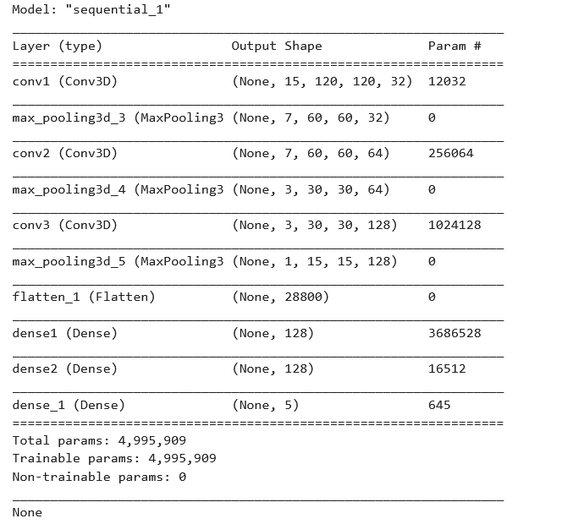epochs = 20, optimizer = adam
   4. Model summary:
   5. LR = ReduceLROnPlateau(monitor='val_loss', factor=0.2, patience=5, min_lr=0.001)
   6. Steps per epoch = 2 (using only 2 batches to over fit the model)
   7. Output:
      1. OOM out of memory error
2. Exp3: cropping images and reducing batch size to 50 and remaining all same from above – overfitting the model on only 2 batches
   1. Batch size = 50, frames per image (x) = 15 (skipping alternate frames), height (y) x width (z) = 120 x 120
   2. cropping 60x60 for 360x360 images = 300x300 and 0x20 for 120x160 images = 120x140
   3. resize using imresize (shape = y, z)
   4. normalize = min max normalization,
   5. epochs = 20, optimizer = adam
   6. Model summary:
   7. LR = ReduceLROnPlateau(monitor='val_loss', factor=0.2, patience=5, min_lr=0.001)
   8. Steps per epoch = 2 (using only 2 batches to over fit the model)
   9. Output:
      1. training accuracy : 22%
      2. validation accuracy: 22%
      3. training loss: 1.6007
      4. validation loss: 0.2200

The model is indeed learning as there is clear sign of improvements in accuracy and loss of training and validation.

1. Exp3: trying to overfit on all batches remaining all same from above
   1. Batch size = 50, frames per image (x) = 15 (skipping alternate frames), height (y) x width (z) = 120 x 120
   2. cropping 60x60 for 360x360 images = 300x300 and 0x20 for 120x160 images = 120x140
   3. resize using imresize (shape = y, z), normalize = min max normalization,
   4. epochs = 20, optimizer = adam
   5. Model summary:
   6. LR = ReduceLROnPlateau(monitor='val_loss', factor=0.2, patience=5, min_lr=0.001)
   7. Steps per epoch = num of batches
   8. Output:
      1. training accuracy : 100%
      2. validation accuracy: 73%
      3. training loss: 0.00027457
      4. validation loss: 3.2748

This is a clear sign of overfitting

1. Exp4: Adding some dropouts to reduce the overfitting
   1. Batch size = 50, frames per image (x) = 15 (skipping alternate frames), height (y) x width (z) = 120 x 120
   2. resize using imresize (shape = y, z), normalize = min max normalization,
   3. epochs = 20, optimizer = adam
   4. Model summary:
   5. LR = ReduceLROnPlateau(monitor='val_loss', factor=0.2, patience=5, min_lr=0.001)
   6. Steps per epoch = num of batches
   7. Output:
      1. training accuracy : 100%
      2. validation accuracy: 73%
      3. training loss: 0.00027457
      4. validation loss: 3.2748

This is a clear sign of overfitting